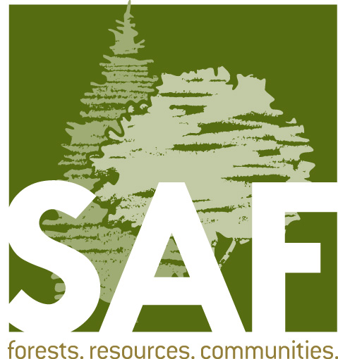

Fellow Nomination/Consent Form

Nominations are due March 1

Fellow nominations are accepted from any SAF member in good standing. All nominations must be submitted via the online submission process. Visit eforester.org/awards for information and to submit a Fellow nomination.

- Nominee Contact Information/Consent:

Nominee’s name:
Address:
City: State: ZIP:
Day Phone: Email:
SAF Membership Number:

I hereby consent to have my name placed in nomination for Fellow. I have reviewed, find it to be accurate, and hereby approve the accompanying biographical sketch.

Signature: _______________________________ Date: _______________________

- Nominator Contact Information:

Nominator’s name:
Address:
City: State: ZIP:
Day Phone: Email:

As the nominator, please select which category or categories the nominee should be considered under
(see criteria for descriptions):

Application of Forestry Education Public Policy Research Technology Transfer

- Check List (your nomination packet must contain the following):
- The nomination/consent form;
- Three completed endorsement forms outlining the nominee’s accomplishments;
- A completed biographical and professional information form or curriculum vitae; and
- A recent digital photo with a minimum of 300 dpi.

- Submit all nomination material via the online submission process accessed at eforester.org/awards. Documents will be uploaded individually on the submission site, so do not combine into a single pdf.

- Questions? Email awards@safnet.org

